**COAL LAB MID (21K-4827)**

Q.1)

A)

Include irvine32.inc

.data

MYNAME byte "MUHAMMAD MUBIN FARID",0

.code

main PROC

mov eax,0

mov edx,0

mov edx,offset MYNAME

call writestring

call crlf

mov esi,offset MYNAME

mov eax,[esi]

mov ecx,lengthof MYNAME

l1:

inc esi

add eax,[esi]

call dumpregs

loop l1

exit

main ENDP

END main

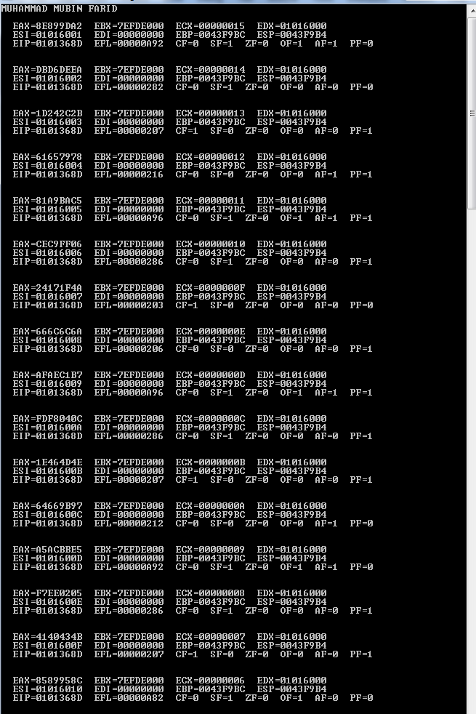

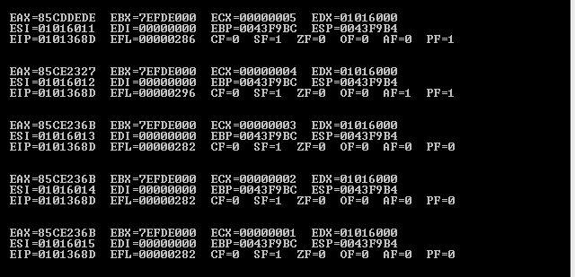

B)

Include irvine32.inc

.data

AB sbyte 65o,-03Ah,-70

AW sword -45Ah,10101010b,5Ch

.code

main PROC

mov eax,0

mov edx,0

mov al,AB[esi*type sbyte]

add esi,2

add al,AB[esi*type sbyte]

mov ebx,eax

call writeint

call crlf

mov eax,0

mov edx,0

mov ax,AW[esi*type sword]

add esi,2

add ax,AW[esi*type sword]

mov edx,eax

call writeint

call dumpregs

exit

main ENDP

END main

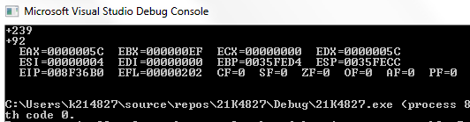

Q.2)

Include irvine32.inc

.data

array sbyte 10 DUP(?)

.code

main PROC

mov eax,0

mov ebx,0

mov edx,0

mov esi,offset array

mov ecx,10

l1:

mov eax,+27

sub eax,-48

call randomrange

add eax,-48

mov [esi],eax

call writeint

call crlf

inc esi

loop l1

exit

main ENDP

END main

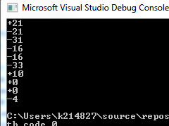

Q.3)

Include irvine32.inc

.data

space byte " ",0

star byte "*",0

.code

main PROC

mov eax,0

mov ebx,0

mov edx,0

mov ecx,5

l1:

mov ebx,ecx

mov eax,6

sub eax,ebx

mov ecx,ebx

l3:

mov edx,offset star

call writestring

loop l3

call crlf

mov ecx,eax

l2:

mov edx,offset space

call writestring

loop l2

mov ecx,ebx

loop l1

exit

main ENDP

END main

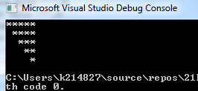

Q.4)

Include irvine32.inc

.data

myname byte "MUBIN",0

.code

main PROC

mov eax,0

mov edx,0

mov ecx,10

l1:

mov ebx,ecx

mov ecx,250000000

l3:

loop l3

mov al,50

call randomrange

mov dh,al

mov al,100

call randomrange

mov dl,al

call gotoxy

mov edx,offset myname

call writestring

mov ecx,ebx

loop l1

exit

main ENDP

END main

